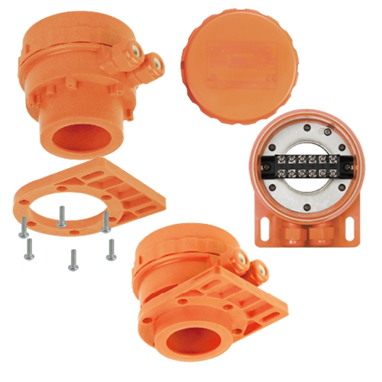

**Type Y3C6**

**Polypropylene immersion heater enclosure for surface treatment baths**

Plastic enclosures, highly corrosive environments. These enclosures are in polypropylene. Plastic terminals can be added.

Size (mm): 105x95.

Volume (cm3): 663.

Ingress protection: IP69K.

Level of impact resistance: IK10.

Suitable for: Thermostat, Immersion heater.